# Preparation session 7/03

## Introduction

For this session everyone had to do research on an assigned topic. Mine was to do some research on the Microcontroller.

## NodeMCU

The microcontroller that best fit our needs is the nodeMCU as it is cheap and does everything we need.

NodeMCU is actually a ‘development board’ containing components like the IC ESP8266 which runs the firmware, USB to serial converter CH340G, and many others.   
A development board adds all kinds of components to a base IC (in this case the ESP8266) to make it useable without any external components.   
So the NodeMCU is a ‘package’ which lets the user work with the ESP8266.

The NodeMCU is made by a third party, so not the same company that made the ESP8266, which is ‘Espressif’, an electronics company based in Shanghai.   
The developers of NodeMCU made all the firmware and development kits opensource on their GitHub [1].

NodeMCU firmware is programmed in the ‘lua’ language with a programming model similar to NodeJS.   
As none of us know ‘lua’, we will be using an IDE (Integrated Development Environment) so we can write in a language that suits us. There are plenty of IDE’s that use java, python, c, pascal, …. a list can be found here [2].

A collection of existing modules programmed by the NodeMCU team can be found here [3]

The Github also contains the pin layout: 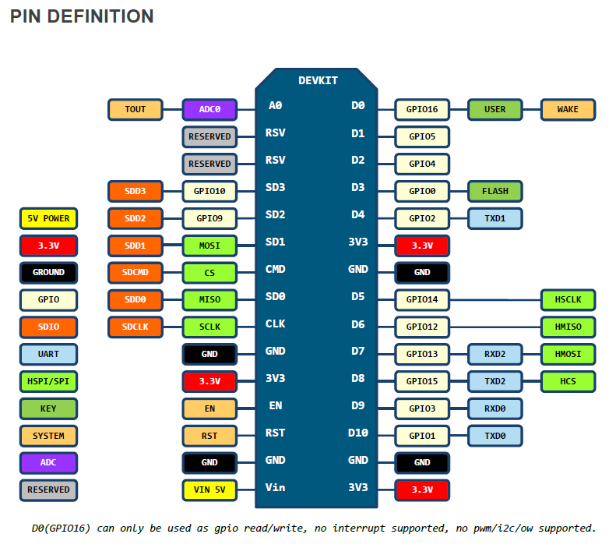

# Bibliografie

|  |  |
| --- | --- |
| [1] | GitHub, „NodeMCU,” Github, [Online]. Available: https://github.com/nodemcu. [Geopend 6 Maart 2018]. |
| [2] | Frightanic, „Tools and IDE's NodeMCU,” Frightanic, [Online]. Available: https://frightanic.com/iot/tools-ides-nodemcu/. [Geopend 07 Maart 2018]. |
| [3] | NodeMCU, „NodeMCU Documentation,” NodeMCU, [Online]. Available: https://nodemcu.readthedocs.io/en/master. [Geopend 7 Maart 2018]. |